* Introduction to Python

1. Write a Python program that prints "Hello, World!".

* Create a new file named hello.py and write:

print(“Hello, World!”)

1. Set up Python on your local machine and write a program to display your name.

* First Download Python from python.org/downloads.
* Install it (make sure to check a add a python to a path during installation
* To verify installation, open terminal (or command prompt) and type:
* Python –version
* Create another file name as myname.py and write:
* print(“My name is Krishna Yadav”)
* Output :

My name is Krishna Yadav

* Programming Style

1. Write a Python program that demonstrates the correct use of indentation, comments, and variables following PEP 8 guidelines.

* Core Python Concept

1. Write a Python program to demonstrate the creation of variables and different data types.
2. Practical Example 1: How does the Python code structure work?
3. Practical Example 2: How to create variables in Python?
4. Practical Example 3: How to take user input using the input() function.
5. Practical Example 4: How to check the type of a variable dynamically using type().

Ans. 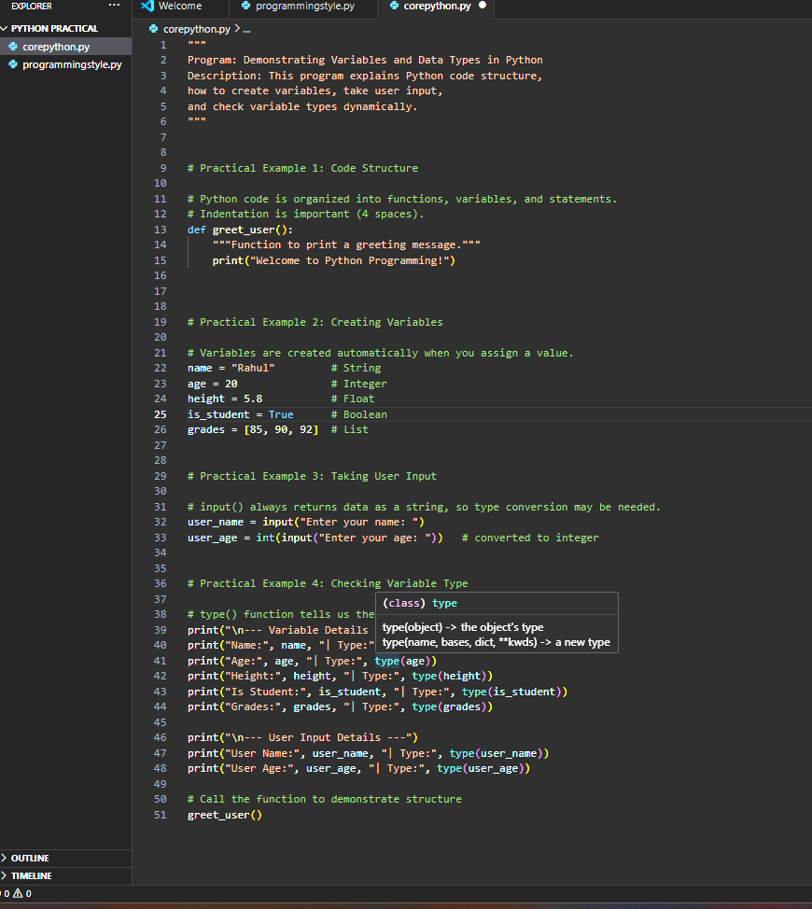

* Conditional Statement

1. Practical Example 5: Write a Python program to find greater and less than a number using

if_else.

1. Practical Example 6: Write a Python program to check if a number is prime using if_else.
2. Practical Example 7: Write a Python program to calculate grades based on percentage using

if-else ladder.

1. Practical Example 8: Write a Python program to check if a person is eligible to donate blood

using a nested if.

* Looping (For, While):

1.Practical Example 1: Write a Python program to print each fruit in a list using a simple for loop. List1 = ['apple', 'banana', 'mango']

2. Practical Example 2: Write a Python program to find the length of each string in List1.

3. Practical Example 3: Write a Python program to find a specific string in the list using a simple

for loop and if condition.

4. Practical Example 4: Print this pattern using nested for loop:

markdown

Copy code

*

-––-

**

***

****

*****

* Generators and Iterators

1. Write a generator function that generates the first 10 even numbers.
2. Write a Python program that uses a custom iterator to iterate over a list of integers.

* Functions And Methods

1. Practical Example: 1) Write a Python program to print "Hello" using a string.
2. Practical Example: 2) Write a Python program to allocate a string to a variable and print it.

1. Practical Example: 3) Write a Python program to print a string using triple quotes.

1. Practical Example: 4) Write a Python program to access the first character of a string using index value.
2. Practical Example: 5) Write a Python program to access the string from the second position

onwards using slicing.

1. Practical Example: 6) Write a Python program to access a string up to the fifth character.

1. Practical Example: 7) Write a Python program to print the substring between index values 1

and 4.

1. Practical Example: 8) Write a Python program to print a string from the last character.

1. Practical Example: 9) Write a Python program to print every alternate character from the

string starting from index 1.

* Control Statement (Break, Continue, Pass)

1. Practical Example: 1) Write a Python program to skip 'banana' in a list using the continue statement. List1 = ['apple', 'banana', 'mango']
2. Practical Example: 2) Write a Python program to stop the loop once 'banana' is found using the break statement.

* Slicing Methods

1. Write a Python program to demonstrate string slicing.
2. Write a Python pro
3. gram that manipulates and prints strings using various string methods.

* Advance Python

1. Write a Python program to apply the map() function to square a list of numbers.
2. Write a Python program that uses reduce() to find the product of a list of numbers.
3. Write a Python program that filters out even numbers using the filter() function.